# Practices DQ Monitoring

### Practice 1: Read Breakfast_Items and Manufacturers with an import

Navigate to the Folder: /gelcontent/dqdashboard/data/

Add the BREAKFAST_ITEMS.xlsx, then add an import step.

Analyze the columns and store the result in a table SASDM.BREAKFAST_ITEMS

Add the MANUFACTUERS.xlsx, then add an import step.

Analyze the columns and store the result in a table SASDM.MANUFACTURERS

In order to check the values in BREAKFAST_ITEMS: UPC, UOM and BRAND, add a One-Way Frequencies Step to the Breakfast_Items table:

In options unselect include cumulative frequencies and percentages:

In order to check the values in MANUFACTURERS fields: COUNTRY, STATE_PROV, CONTACT_CNTRY, CONTACT_STATE_PROV add a One-Way Frequencies Step to the MANUFACTURERS table:

Finally, Standardize the COUNTRY and STATE_PROV fields in the MANUFACTURERS table:

Using a Clean Data step:

### Practice 2: Add 2 discovery Agents as an SAS Viya Administrator for SASDM Compute and Public Caslib.

Login to SAS Viya as sasadm & lnxsas.

Go to Discover Information Assets

Select Discovery Agents

Select new Discovery Agent and choose the compute library SASDM.

No changes are required in the configuration:

Select Run Now. This will save the discovery agent and run the Discovery Agent.

Same can be done for the PUBLIC Caslib.

### Practice 3: Go to Discover Information Assets as Alex and search for the Breakfast_Items table.

Search for the Breakfast_Items table:

Select the Table and look at the Overview page:

Select column analysis:

Investigate the columns UPC, UOM and BRAND.

* What is the completeness of each field?
* For UPC and UOM what is the most common Pattern?

Close the Breakfast_items table

Now search for the Manufacturers table:

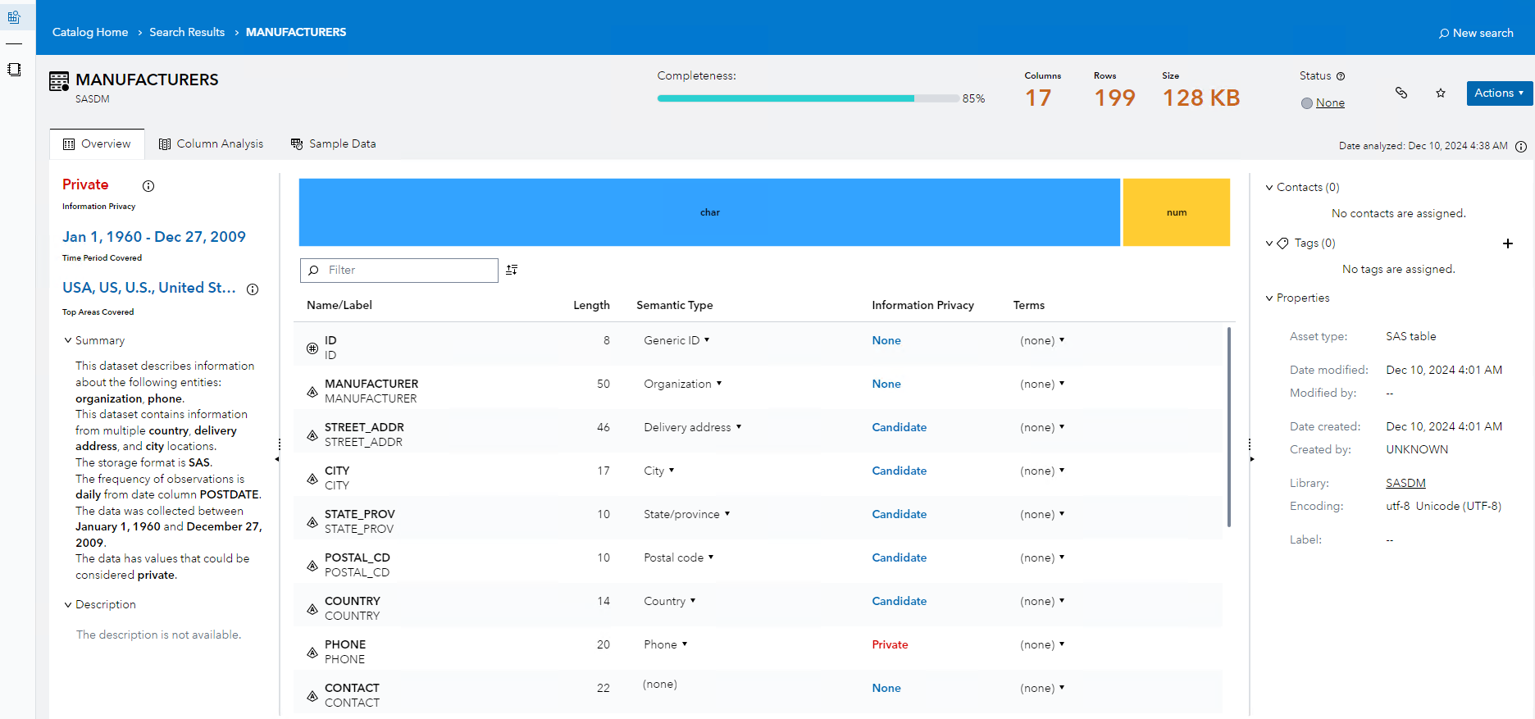

In the column analysis, investigate the completeness and Frequency Distribution of different fields:

What is the completeness of Street_addr, STATE_PROV, COUNTRY

### Practice 4: Create Ruleset to check Validity of UPC (Uniform Product Code) in Breakfast_Items:

1. create Validity_UOM Ruleset:

Duplicate the Ruleset Validity_Phone and save as Validity_UOM

* Rename Variables isAccuracy_UOM (Boolean), Value_UOM (string)

On the Rule Set tab:

* Rule: Validity_UPC
* Dimension: Validity
* Rule_Description: Checking type and length of UPC
* Expression:

Assign: isValidity_UPC True

Change the custom expression to the expression below. It uses a Regex to check if not numbers are found in the Value_UPC and if the length is not 14 long.

Value_UPC= STRIP(Value_UPC)

re= prxparse('/^\d+$/');

if ^prxmatch(re,Value_UPC) and length(Value_UPC) ^= 14 then do;

isValidity_UPC= 0;

end;

1. Create a Decision Field_UPC

Select Decisions: select Field_Phone, check the checkbox, then top left menu: duplicate. Rename the Decision to Field_UPC

Select the variables tab, rename all variables and initial values from Phone to UPC

Remark: sometimes a variable rn also contains an initial value that needs to be renamed:

After the renaming, the variables tab should like like following screen:

On the Decision Flow, remove the Validity_Phone Ruleset and Add to the No Branch after the Completeness check, the Validity_UPC Ruleset

Then add to the No branch the Validity_UPC Ruleset:

Check the mappings of the Input and Output variables. The Value_UPC in the decision should be mapped to the Value_UPC in the Ruleset. Same for the isValidity_UPC.

### Practice 5: Create Ruleset to check Accuracy of UOM (Unit of Measure)

1. Create Lookup Table UOMLookup:

CT=Carat, LB=Pound, OZ=Ounce, PK=Peck

Store the lookup table and Activate it

1. create Accuracy_UOM Ruleset:

Duplicate the Ruleset Accuracy_County and save as Accuracy_UOM

* Rename Variables isAccuracy_UOM (Boolean), Value_UOM (string)
* Rule: UOM Check
* Rule_Description: Checking the values for UOM
* Assign isAccuracy_UOM False
* Add Rule: if Value_UOM Lookup UOMLookup THEN then isAccuracy_UOM=true

1. Create a Decision Field_UOM

Select Decisions: select Field_County, check the checkbox, then top left menu: duplicate

Rename the Decision to Field_UOM.

Select the variable tab, rename all variables and initial values from County to UOM

On the Decision Flow, remove the Accuracy_County Ruleset and Add to the No Branch after the Completeness check, the Accuracy_UOM Ruleset

Check the mappings of the Input and Output variables. The Value_UOM in the decision should be mapped to the Value_UOM in the Ruleset. Same for the isAccuracy_UOM.

### Practice 6: Create a Monitoring Task: Mon_Breakfast_items

Start with a Duplicate of Mon_Person Decision.

Delete all the Field_ decisions from the flow, then delete the variables.

Add Variables from the Field_UOM and Field_UPC decisions from /Public/DataManagement/DQDashboard/Monitor Data Quality

On the Decision Flow, add the Field_UOM and Field_UPC Decisions from the folder

The resulting Monitor Task Decision flow should look like:

Select Scoring, add a new Test:

Select Breakfast_items and map the columns UPC and UOM to Value_UPC and Value_UOM.

Run the test, check if the test is successful.

